Databrowse Quick Start Guide

This guide will provide a quick walk-through of functionality available in the Databrowse system. Please be aware that Databrowse is still a work-in-progress. There may be some bugs, particularly in the way things are displayed on the screen. Please report any error messages received or anything that does not display correctly to Tyler Lesthaeghe at tylerl@iastate.edu.

What is Databrowse?

Databrowse is a tool for visualizing directories and files, with an emphasis on the display of structured data and extensibility. At the core level, Databrowse is a file browser. Built on top of that are plugins that manipulate and display data in useful and meaningful ways. Data stored in structured tag formats, while human readable, are not particularly easy to open and read, let alone interpret. Databrowse fills this void by transforming the data into something meaningful. Databrowse also allows users to preview or view some kinds of data that may require special software or a special environment to examine. Additionally, Databrowse allows remote users to access files directly from the central file storage location, securely over the Internet, without the need for direct access to the machine the data is being stored on or needing to go through the hassle of remotely connecting.

Logging on to Databrowse
We recommend the use of Mozilla Firefox (http://www.mozilla.org/firefox/) or Google Chrome (http://www.google.com/chrome) when using the Databrowse system. Microsoft Internet Explorer is generally not supported. Microsoft Edge has been preliminarily tested and appears to function properly; however, extensive testing has not yet been completed.
Open the link below in your web browser to access the Databrowse system.
ISU Faculty, Staff, and Students:
https://pequod.cnde.iastate.edu/databrowse
Individuals without an ISU NetID:
https://pequod.cnde.iastate.edu/databrowse-external
If you receive access denied error messages, please send an e-mail to tylerl@iastate.edu for additional assistance.

Features of Interest
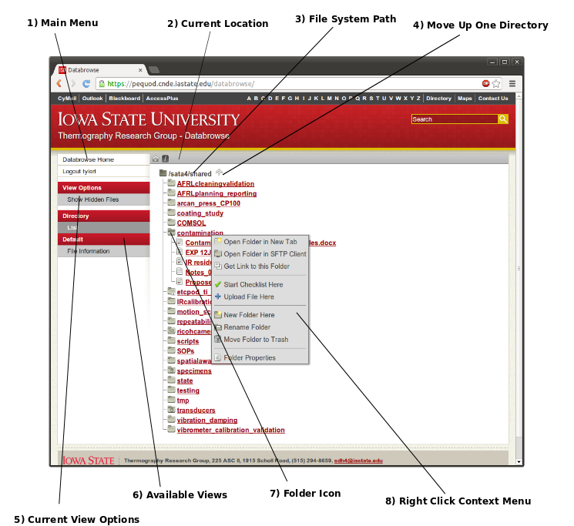
1 | Main Menu  Contains links to jump to the the data directory root, logout, and switch views | 5 | Current View Options  Displays a list of options available to modify the current view
2 | Current Location  Displays the location of the current view relative to the data directory root – click a folder name to jump to it | 6 | Available Views  Displays a list of various plugins that are capable of rendering the current file or folder and views available within those plugins
3 | File System Path  Displays the absolute path of the current view in the file system | 7 | Folder Icon  Click this folder icon to expand the folder and dynamically load the contents of the sub folder
4 | Move Up One Directory  Click this link to move up one directory until you reach the data directory root | 8 | Right Click Context Menu  Right click the name of any folder or file in this view to display this context menu
Creating New Directories
The following steps can be used to create new directories from Databrowse:
1) | Navigate to the Folder that will Contain the New Folder  Using the Databrowse interface, locate the folder that will contain the folder you wish to create.
2) | Right Click Folder Name to Open Context Menu  Using the mouse, right click on the name of the folder you wish to contain your new folder. If the current view is the location you wish to create a new folder within, right click on the black text at the top. This is the shaded area shown on the figure to the right. | 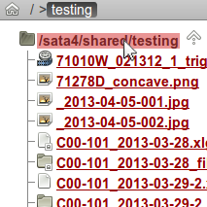
3) | Select New Folder Here from the Context Menu | 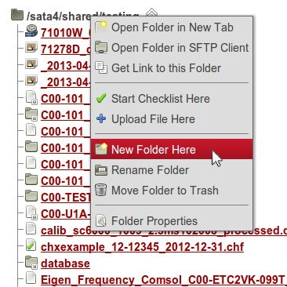
4) | Type a Name and Click OK  Type a name for your new folder. Spaces and special characters may be used in folder names; however, their use is discouraged. | 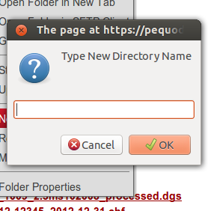
5) | Finished!  You will be taken to the new folder automatically.

Uploading Files
The following steps can be used to upload files using Databrowse:
1) | Navigate to the Folder in which you wish to Upload Files  Using the Databrowse interface, locate the folder that will contain the files you wish to upload.
2) | Right Click Folder Name to Open Context Menu  Using the mouse, right click on the name of the folder you wish to contain your new folder. If the current view is the location you wish to upload files to, right click on the black text at the top. This is the shaded area shown on the figure to the right.
3) | Select Upload Files Here from the Context Menu
4) | Click Add Files to Open the File Selection Box  Inside the file selection box, you may hold Shift or Ctrl on the keyboard to select multiple files. Select Open once you have chosen the file you wish to upload. Repeat for additional files to be uploaded. The options you have selected will appear in the window.  Alternatively, Drag and Drop Files into Upload Window  Using Windows Explorer, Finder, or Natuilus, depending on your operating system, you may drag files into the open space on the upload window. The files will appear in the window. | 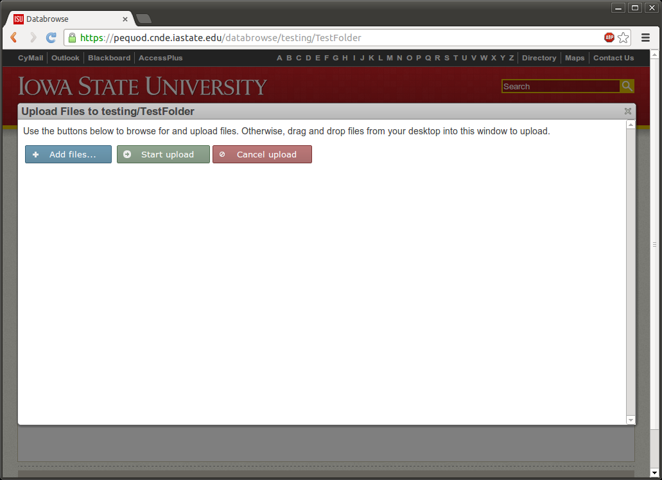
5) | Click Start Upload  You should see progress bars indicating the length of time remaining to upload your files. If uploading photos, you will see a preview thumbnail of the photo. | 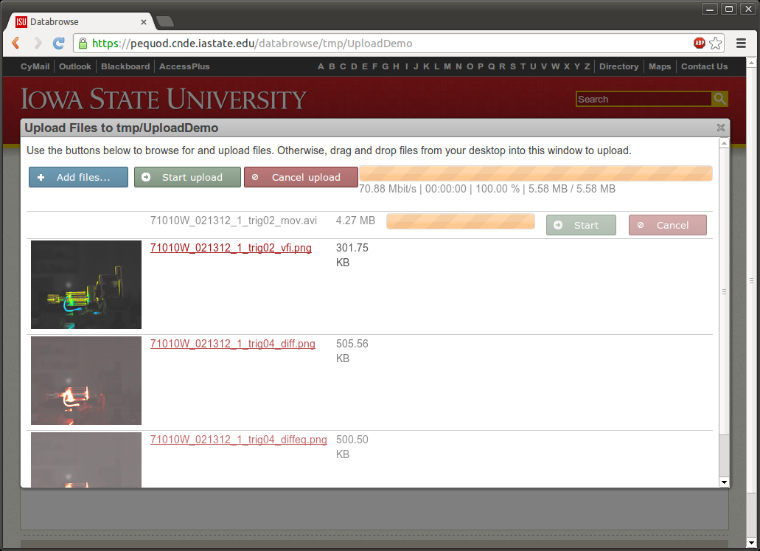
6) | Click the X or Click Outside of the Upload Window to Close  The page will automatically refresh to show your new files. Do not close the window while uploading is still taking place or your upload will be interrupted.

Downloading Files and Folders
The following steps can be used to download files and folders as a compressed zip file using Databrowse:
1) | Navigate to the Folder or File you wish to Download  Using the Databrowse interface, locate the folder that contains the file or folder you wish to download.
2) | Right Click Folder or File Name to Open Context Menu  Using the mouse, right click on the name of the folder you wish to contain your new folder. If the current view is the location you wish to download, right click on the black text at the top. This is the shaded area shown on the figure to the right.
3) | Select Download Folder/File as Zip File | 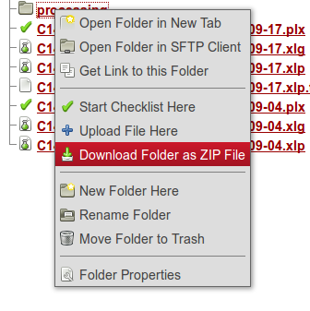
4) | Finished!  Your download will start shortly.

